## Product

Artificial intelligence based virtual office assistant system for business centers. It can increase productivity of your existing secretaries or fully replace them. It is an information kiosk-like device with voice control, touch screen, camera, speakers and ticket printer. Customer can contact desired office via full HD video call feature and representative can let them. People also can ask information about toilets, lifts on premises/nearby cafes and restaurants, parking, etc.

## Features

Voice recognition

The device has built in voice recognition and can be controlled via voice command, for example “can I contact company X”.

Face recognition

Device actives as soon as camera detects a face of a person facing/looking at the device.

Video call function

Device can make full HD crisp quality video calls to office representative. Both parties will be able to see and hear each other.

Advance visitor

If office is equipped with entry gates, visitor can be sent advance electronic ticket with unique QR code.

Ticket printer

Device can be equipped with ticket printer and visitor will be issued physical entry ticket for entry and exit.

Multi language

Device can be interacted by multiple languages: English and any other. 3 languages can be supported as well.

Cloud technologies

We use most advanced Google and Amazon cloud technologies in our solution to ensure reliability of our service

Touch screen

Use intuitive web like touch interface if you having problems communicating using voice commands.

Interactive map

Show map/ floor plan with glowing your location and location of your destination.

Offline mode

If device goes offline it detect it and show direct telephone numbers of each company.

Pricing

Price is composed of set-up fee to tailor our solution to your needs and monthly maintenance fee. Solution can have one or more devices installed ant multiple entrances of your business center and many client side (business center tenants) terminals. Please contact us for details.

AI + Software + Hardware

We build Virtual Assistant that can Replace business office secretary

Key features:

* AI voice recognition – speak to the device
* Text to speech – listen for answers and instructions
* Touch screen menu – if one does not like voice commands
* Directions are spoken and shown on screen
* Print entry tickets/labels
* Arrange visits in advance – sent entry tickets by email
* Video call function - you can speak to desired office secretary
* Multilanguage support – English and local language(-s)
* Face recognition – device will activate if you face it

You can ask device:

* Where can I eat - it will direct you to nearest restaurant
* Where is specific company - it will direct you to the company office
* Were toilets are located – see instructions
* Where can you have a pint of beer – it will direct you to the nearest bar
* Where is parking – it will direct you the entrance of underground parking
* What time is now?
* What is the meaning of life?

We can adapt out product to specific needs of your business Centre

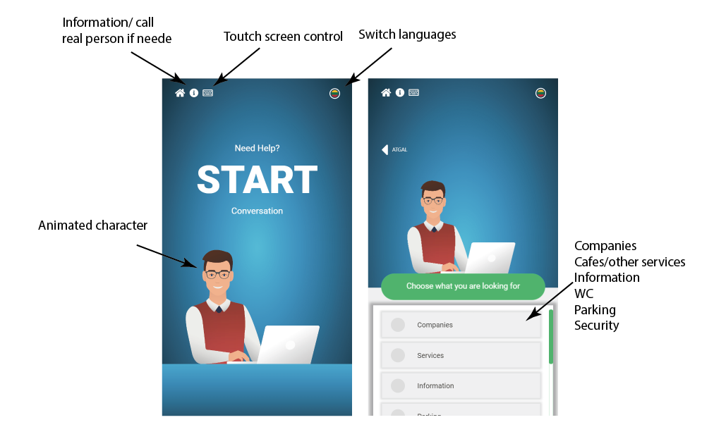

We have AI (voice recognition, face recognition) and text-to-speech experience. We have design and app development and hardware skill

We specialize in complex projects, that involve image recognition, voice recognition, nice design, cloud technologies and hardware.

Interactive voice controlled shopping center maps

Interactive virtual assistant for business center – can replace secretary at the entrance of the office

Features:

Voice command recognition

Map

Audio directions instructions

Interactive destination highlighting

Interactive path displays as an arrow

Save 1000 EUR on secretary - use virtual assistant kiosk

----

Ka reikia ideti I marketinga medziama

How can I help you

Where I can find some company

Call some company

What is weather

Map spoken directions